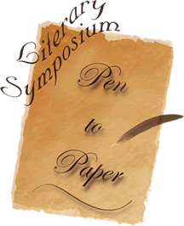

The Art Of Writing
Friday, September 30, 2005
12:00 pm to 6:30 pm

The Business Of Writing
October 1, 2005
8:00 am to 5:00 pm

Holiday Inn Dayton South
2455 Dryden Road
Dayton, Ohio
937.294.1471

The Art Of Writing – Nationally recognized editors will step you through the process of writing. Genre-specific topics and general sessions will help you hone your craft and catapult your literary works to the next level.

The Business of Writing – Seasoned veterans will provide practical tools to manage your business from filing taxes, controlling costs and publicity. Mainstream and self-published authors will enlighten and inspire you to pursue your life passion.

Our objective is to assist aspiring writers and authors through the process of self-publishing by providing industry experts and insight from published authors.

A portion of the proceeds will be donated to Project Impact to support youth literacy in the Dayton community.

Registration includes:
Registration Deadline
September 15, 2005

Registration Fee
$189

Visit www.butterflypress.net
- Conference meals
- Writing workshops
- Self-publishing seminars
- Souvenir journal and registration materials
- Access to industry experts and exhibitors
- Networking with published authors
- On-site bookstore
- Volumes of information

For an additional fee, one-on-one critiques by professional editors will give you personalized feedback about your manuscript.

For additional information contact:
Early bird discounts through March 31!
Valerie Coleman
PMB 257 - 5523 Salem Avenue
Dayton, Ohio 45426
937.307.0760
symposium@butterflypress.net

